**MACEDONIA ENDOSCOPY DEVICES MARKET**

According to Intelli, the Macedonia endoscopy devices market was valued at USD 7 million in 2024 and is projected to reach USD 13.5 million by 2032, growing at a CAGR of 9% from 2024 to 2032.

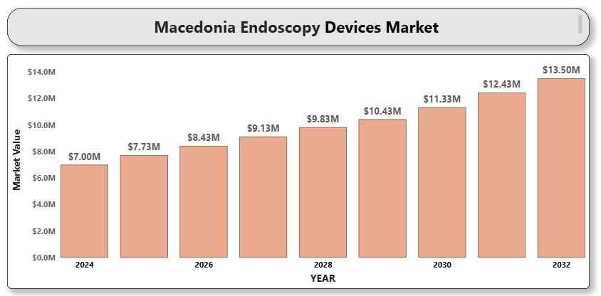

The endoscopy devices market in Macedonia is witnessing steady growth, driven by rising incidences of gastrointestinal disorders, cancers, and chronic diseases requiring minimally invasive diagnostic and therapeutic procedures. Technological advancements in endoscopic imaging, an increasing preference for minimally invasive surgeries, and government initiatives to modernize healthcare infrastructure are key growth drivers. The shift toward outpatient endoscopic procedures and the increasing aging population further contribute to the growing demand for advanced endoscopy solutions.

**Macedonia Endoscopy Devices Market Definition**

Endoscopy devices are medical instruments used to visualize, diagnose, and treat conditions within internal organs and cavities of the body using minimally invasive techniques. These devices include endoscopes, visualization systems, operative devices, and accessories. They are widely used across gastrointestinal, urology, gynecology, pulmonary, and orthopedic specialties in hospitals, ambulatory surgical centers, and specialty clinics. Endoscopy devices play a critical role in early disease detection, significantly improving patient outcomes by enabling less invasive diagnostic and therapeutic procedures compared to traditional open surgeries. The evolution of high-definition imaging, 3D visualization, and capsule-based endoscopy has enhanced the effectiveness and precision of these devices. In Macedonia, the integration of digital technologies into endoscopic platforms, coupled with increasing healthcare awareness, is boosting the demand for these devices across both public and private healthcare facilities.

**Macedonia Endoscopy Devices Market Overview**

Several factors are driving the Macedonia endoscopy devices market. These include increasing disease burden, technological improvements in flexible endoscopes, and greater awareness about the benefits of early disease detection. However, challenges such as high device costs, shortage of skilled endoscopists, and stringent regulatory requirements remain. Nevertheless, growing healthcare investments and collaborations with international players provide significant market opportunities. The market is also influenced by rising patient preference for minimally invasive diagnostic solutions, shorter hospital stays, and faster recovery times. Innovations such as robotic-assisted endoscopy and disposable endoscopes are setting new trends in the Macedonian healthcare landscape. Moreover, training programs for healthcare professionals and efforts to expand endoscopic services to rural areas are expected to further support the growth of the endoscopy devices market in Macedonia.

**Macedonia Endoscopy Devices Market Segmentation Analysis**

**Market Segmentation by Product Type**

* **Endoscopes**
* **Visualization Systems**
* **Operative Devices**
* **Other Accessories**

*Endoscopes* accounted for the largest share of the market in 2024 due to widespread usage across multiple medical specialties. Technological innovations like capsule endoscopy and robotic-assisted endoscopy are further expanding this segment.

**Market Segmentation by End-User**

* **Hospitals**
* **Ambulatory Surgical Centers (ASCs)**
* **Specialty Clinics**

*Hospitals* dominated the market in 2024, owing to the availability of advanced diagnostic equipment and comprehensive patient care services. Meanwhile, *ambulatory surgical centers* are growing fast, benefiting from shorter procedure times and cost efficiencies.

**Market Segmentation by Technology**

* **Flexible Endoscopes**
* **Rigid Endoscopes**
* **Capsule Endoscopy**

*Flexible endoscopes* are the most widely used, given their versatility, patient comfort, and expanding applications across specialties. *Capsule endoscopy* is also gaining popularity for non-invasive gastrointestinal diagnostics.

**Market Segmentation by Application**

* **Gastrointestinal (GI) Endoscopy**
* **Laparoscopy**
* **Obstetrics/Gynecology Endoscopy**
* **Arthroscopy**
* **Bronchoscopy**
* **Other Applications**

*Gastrointestinal endoscopy* remains the largest application area, driven by the high prevalence of digestive disorders and increased screening for colorectal cancers.

**Key Players**

The "Macedonia Endoscopy Devices Market" study highlights major players such as:

* Olympus Corporation
* Boston Scientific Corporation
* Medtronic PLC
* Stryker Corporation
* Karl Storz SE & Co. KG
* Fujifilm Holdings Corporation
* Richard Wolf GmbH
* Smith & Nephew PLC
* PENTAX Medical (HOYA Group)
* Cook Medical

Our analysis includes financial performance insights, product benchmarking, and SWOT analysis for all major players.

**Key Developments**

* In 2024, Medtronic unveiled **ColonPRO™**, the latest software upgrade for its **GI Genius™** intelligent endoscopy system.
* 1n 2024, A close-up of hands holding a tablet and a pen

  Description automatically generatedOlympus introduced the **VISERA S**, an all-in-one imaging platform designed to enhance diagnostic capabilities in Ear, Nose, and Throat (ENT) procedures.
* In early 2024, Boston Scientific announced the European launch of its **EXALT™ Model D**, a single-use duodenoscope designed to reduce the risk of cross-contamination in endoscopic retrograde cholangiopancreatography (ERCP) procedures.

**Market Attractiveness**

The market attractiveness analysis highlights the most lucrative segments based on market growth potential, profitability, competition intensity, and technological advancements. Products like capsule endoscopes and single-use endoscopes are seen as particularly attractive investment areas in Macedonia.

**Porter's Five Forces**

A Porter’s Five Forces analysis assesses the strategic positioning of companies operating in the Macedonia endoscopy devices market:

* **Threat of New Entrants:** Moderate
* **Bargaining Power of Suppliers:** Low to Moderate
* **Bargaining Power of Buyers:** High
* **Threat of Substitute Products:** Low
* **Competitive Rivalry:** High

The analysis suggests a highly competitive market with established players dominating, though opportunities exist for innovative new entrants.

**TABLE OF CONTENT**

**1 INTRODUCTION OF MACEDONIA ENDOSCOPY DEVICES MARKET**

* 1.1 Overview of the Market
* 1.2 Scope of Report
* 1.3 Assumptions

**2 EXECUTIVE SUMMARY**

**3 RESEARCH METHODOLOGY**

* 3.1 Data Mining
* 3.2 Validation
* 3.3 Primary Interviews
* 3.4 List of Data Sources

**4 MACEDONIA ENDOSCOPY DEVICES MARKET OUTLOOK**

* 4.1 Overview
* 4.2 Market Dynamics
  + 4.2.1 Drivers
  + 4.2.2 Restraints
  + 4.2.3 Opportunities
  + 4.2.4 Trends
* 4.3 Porter’s Five Forces Model
* 4.4 Value Chain Analysis

**5 MACEDONIA ENDOSCOPY DEVICES MARKET, BY PRODUCT TYPE**

* 5.1 Endoscopes
* 5.2 Visualization Systems
* 5.3 Operative Devices
* 5.4 Other Accessories

**6 MACEDONIA ENDOSCOPY DEVICES MARKET, BY END USER**

* 6.1 Hospitals
* 6.2 Ambulatory Surgical Centers (ASCs)
* 6.3 Specialty Clinics

**7 MACEDONIA ENDOSCOPY DEVICES MARKET, BY TECHNOLOGY**

* 7.1 Flexible Endoscopes
* 7.2 Rigid Endoscopes
* 7.3 Capsule Endoscopy

**8 MACEDONIA ENDOSCOPY DEVICES MARKET, BY APPLICATION**

* 8.1 Gastrointestinal (GI) Endoscopy
* 8.2 Laparoscopy
* 8.3 Obstetrics/Gynecology Endoscopy
* 8.4 Arthroscopy
* 8.5 Bronchoscopy
* 8.6 Other Applications

**9 MACEDONIA ENDOSCOPY DEVICES MARKET COMPETITIVE LANDSCAPE**

* 9.1 Overview
* 9.2 Company Market Ranking
* 9.3 Key Development Strategies

**10 COMPANY PROFILES**

* **10.1 Olympus Corporation**
  + 10.1.1 Overview
  + 10.1.2 Financial Performance
  + 10.1.3 Product Outlook
  + 10.1.4 Key Developments
* **A close-up of hands holding a tablet and a pen

  Description automatically generated10.2 Boston Scientific Corporation**
  + 10.2.1 Overview
  + 10.2.2 Financial Performance
  + 10.2.3 Product Outlook
  + 10.2.4 Key Developments
* **10.3 Medtronic PLC**
  + 10.3.1 Overview
  + 10.3.2 Financial Performance
  + 10.3.3 Product Outlook
  + 10.3.4 Key Developments
* **10.4 Stryker Corporation**
  + 10.4.1 Overview
  + 10.4.2 Financial Performance
  + 10.4.3 Product Outlook
  + 10.4.4 Key Developments
* **10.5 Karl Storz SE & Co. KG**
  + 10.5.1 Overview
  + 10.5.2 Financial Performance
  + 10.5.3 Product Outlook
  + 10.5.4 Key Developments
* **10.6 Fujifilm Holdings Corporation**
  + 10.6.1 Overview
  + 10.6.2 Financial Performance
  + 10.6.3 Product Outlook
  + 10.6.4 Key Developments
* **10.7 Richard Wolf GmbH**
  + 10.7.1 Overview
  + 10.7.2 Financial Performance
  + 10.7.3 Product Outlook
  + 10.7.4 Key Developments
* **10.8 Smith & Nephew PLC**
  + A close-up of hands holding a tablet and a pen

    Description automatically generated10.8.1 Overview
  + 10.8.2 Financial Performance
  + 10.8.3 Product Outlook
  + 10.8.4 Key Developments
* **10.9 PENTAX Medical (HOYA Group)**
  + 10.9.1 Overview
  + 10.9.2 Financial Performance
  + 10.9.3 Product Outlook
  + 10.9.4 Key Developments
* **10.10 Cook Medical**
  + 10.10.1 Overview
  + 10.10.2 Financial Performance
  + 10.10.3 Product Outlook
  + 10.10.4 Key Developments

**11 KEY DEVELOPMENTS**

* 11.1 Product Launches/Developments
* 11.2 Mergers and Acquisitions
* 11.3 Business Expansions
* 11.4 Partnerships and Collaborations

**12 APPENDIX**

* 12.1 Related Research